# KARABO

**Address:**

1675 Morolong Section, Kgabalatsane, 0208

**Contact Numbers:** -

063 863 7820 / 083 884 164_2

**Email:**

karabosello2003 mail.com

**SELLO**

## Personal Details

Identity No Date of Birth Gender

Home Language Other Languages Nationality Marital Status Health Status Tax Ref Number

: 030119 0465 08 0

: 19 January 2003

: Female

: Setswana

: English

: South African

: Single

: Good

: 0588180273

## Education

### Grade 12 • 2020 • Micha Kgasi High School

* Setswana, English, Mathematics, Life Orientation, Geography, Life Science, Physical Science

## Work Experience

### CALL CENTER AGENT AT SIDQCON (PTY) Ltd.

* Customer service, Client relationship.
* Closing skills (knowledge of advertising and sales promotion techniques)
* Computer skills (Microsoft Packages - Basic knowledge.
* Meets sales objectives.
* Self confidence, strong interpersonal and communication skills.

## References

Contact Person Position

Contact Number

: Adila(SIDQCON (PTY) Ltd.

: HR(Human Resources).

: (012) 348- 0301

Contact Person Position

Contact Number

: Mr Madisha

: Principal

: 072 1014960

Contact Person Contact Number

: Virginia Sello

: 071 969 6737

**REPUBLIC OF SOUTH AFRICA**

**National Senior Certificate**

*Awarded to*

**KARABO SELLO**

*Identity number* 0301190465080

**S**

|  |  |  |
| --- | --- | --- |
|  | | **Achievement** |
| **ubject** % **level** | | |
| Setswana Home Language | 71 | 6 |
| English First Additional Language | 79 | 6 |
| Mathema1ics | 34 | 2 |
| Life Orientation | 71 | 6 |
| Geography | 57 | 4 |
| Life Sciences | 39 | 2 |
| Physical Sciences | 43 | 3 |
| ************************ ****************************** | ** | * |

*Exam number9201*I I *1200135*

This candidate is awarded !he Nolionol Senior Certificate and hos met !he minimum requirements for admission to diploma or higher certificole study as gazetted for admission lo higher education, subject to the admission requirements of the higher education inslilulion concerned.

*With effect from December* 2020

*Chief Executive Officer*

This cerMcale is Issued wllnaut alterallans or erast.te or any nd

**UMALUSI**



**s.**

Council for Quality Assurance in

General and Further Education and Training South Africa 1 8 5 9 9 55

R.EP.UBl]C Cf SOUTH AFRICA

•

·NATIONAL IDENTITY CARD

Surnan1t::

SEILO

t•l n1es,

# ·KARMO

**F**

'••.•

**RSA**

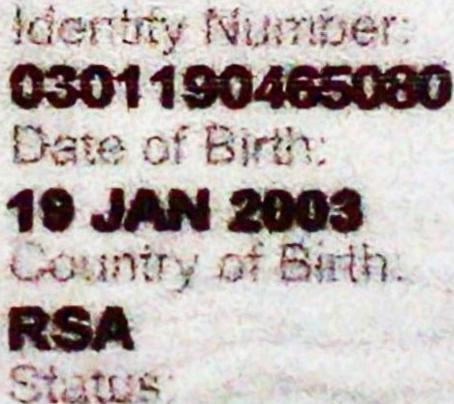D

**Cl11ZEN**